**Data Science**

**Capstone Project**

**Title -** **The Battle of Neighborhoods**

**Submitted By -Nikhil Jain**

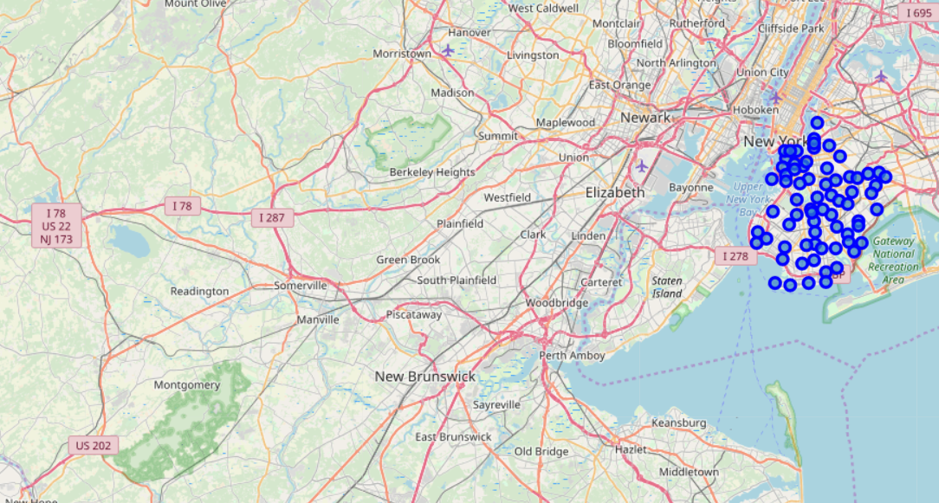

S

**Introduction**

The City of New York, usually called either New York City (NYC) or simply New York (NY), is the [most populous city](https://en.wikipedia.org/wiki/List_of_United_States_cities_by_population) in the [United States](https://en.wikipedia.org/wiki/United_States). With an estimated 2018 population of 8,398,748 distributed over a land area of about 302.6 square miles (784 km2), New York is also the populated major city in the United States. Located at the southern tip of the state of [New York](https://en.wikipedia.org/wiki/New_York_(state)), the city is the center of the [New York metropolitan area](https://en.wikipedia.org/wiki/New_York_metropolitan_area), the largest [metropolitan area](https://en.wikipedia.org/wiki/Metropolitan_area) in the world by [urban landmass](https://en.wikipedia.org/wiki/Urban_area) and one of the world's most populous [megacities](https://en.wikipedia.org/wiki/Megacity), with an estimated 19,979,477 people in its 2018 [Metropolitan Statistical Area](https://en.wikipedia.org/wiki/List_of_metropolitan_statistical_areas) and 22,679,948 residents in its [Combined Statistical Area](https://en.wikipedia.org/wiki/List_of_Combined_Statistical_Areas). A [global power city](https://en.wikipedia.org/wiki/Global_city), New York City has been described as the [cultural](https://en.wikipedia.org/wiki/Culture_of_New_York_City) [financial](https://en.wikipedia.org/wiki/Wall_Street), and [media](https://en.wikipedia.org/wiki/Media_in_New_York_City) capital of the world, and exerts a significant impact upon commerce, entertainment, research, technology, education, politics, tourism, art, fashion, and sports. The city's fast [pace](https://en.wikipedia.org/wiki/Pace_(speed)) has inspired the term [New York minute](https://en.wiktionary.org/wiki/New_York_minute). Home to the [headquarters of the United Nations](https://en.wikipedia.org/wiki/Headquarters_of_the_United_Nations), New York is an important center for [international diplomacy](https://en.wikipedia.org/wiki/International_diplomacy).

Situated on [one of the world's largest natural harbors](https://en.wikipedia.org/wiki/New_York_Harbor), New York City consists of five [boroughs](https://en.wikipedia.org/wiki/Boroughs_of_New_York_City), each of which is a separate [county of the State of New York](https://en.wikipedia.org/wiki/List_of_counties_in_New_York). The five boroughs – [**Brooklyn**](https://en.wikipedia.org/wiki/Brooklyn)**,**[**Queens**](https://en.wikipedia.org/wiki/Queens)**,**[**Manhattan**](https://en.wikipedia.org/wiki/Manhattan)**,**[**The Bronx**](https://en.wikipedia.org/wiki/The_Bronx)**, and**[**Staten Island**](https://en.wikipedia.org/wiki/Staten_Island) – were consolidated into a single city in 1898. The city and its metropolitan area constitute the premier gateway for legal [immigration to the United States](https://en.wikipedia.org/wiki/Immigration_to_the_United_States). As many as 800 languages are spoken in New York, making it the most linguistically diverse city in the world. New York City is home to more than 3.2 million residents born outside the United States, the largest [foreign-born population](https://en.wikipedia.org/wiki/Foreign_born#Cities_with_largest_foreign_born_populations) of any city in the world. As of 2019, the New York metropolitan area is estimated to produce a [gross metropolitan product](https://en.wikipedia.org/wiki/List_of_U.S._metropolitan_areas_by_GDP) ([GMP](https://en.wikipedia.org/wiki/Gross_metropolitan_product)) of US$1.9 trillion. If greater New York City were a [sovereign state](https://en.wikipedia.org/wiki/Sovereign_state), it would have the [12th highest GDP](https://en.wikipedia.org/wiki/List_of_countries_by_GDP_(nominal)) in the world. New York is home to the highest number of [billionaires](https://en.wikipedia.org/wiki/Billionaire) of any city in the world. New York City traces its origins to a trading post founded by colonists from the [Dutch Republic](https://en.wikipedia.org/wiki/Dutch_Republic) in 1624 on [Lower Manhattan](https://en.wikipedia.org/wiki/Lower_Manhattan); the post was named [New Amsterdam](https://en.wikipedia.org/wiki/New_Amsterdam) in 1626. The city and its surroundings came under English control in 1664and were renamed New York after King [Charles II of England](https://en.wikipedia.org/wiki/Charles_II_of_England) granted the lands to his brother, the [Duke of York](https://en.wikipedia.org/wiki/James_II_of_England). New York served as the [capital of the United States](https://en.wikipedia.org/wiki/List_of_capitals_in_the_United_States#Former_national_capitals) from 1785 until 1790. It has been the country's largest city since 1790. The [Statue of Liberty](https://en.wikipedia.org/wiki/Statue_of_Liberty) greeted millions of [immigrants](https://en.wikipedia.org/wiki/Immigrants) as they came to the U.S. by ship in the late 19th and early 20th centuries and is an international symbol of the U.S. and its ideals of liberty and peace.[[50]](https://en.wikipedia.org/wiki/New_York_City#cite_note-50) In the 21st century, New York has emerged as a global node of [creativity](https://en.wikipedia.org/wiki/Innovation) and [entrepreneurship](https://en.wikipedia.org/wiki/Entrepreneurship), [social tolerance](https://en.wikipedia.org/wiki/Social_tolerance) and [environmental sustainability](https://en.wikipedia.org/wiki/Sustainability), and as a symbol of [freedom](https://en.wikipedia.org/wiki/Freedom) and [cultural diversity](https://en.wikipedia.org/wiki/Cultural_diversity). In 2019, New York was voted the greatest city in the world per a [survey](https://en.wikipedia.org/wiki/Survey_(human_research)) of over 30,000 people from 48 cities worldwide, citing the city's cultural diversity.

The insights derived from analysis will give good understanding of the business environment which help in strategically targeting the market. This will help in reduction of risk. And the Return on Investment will be reasonable.

**Business Problem**

The City of New York is famous for its excelllent cuisine. It's food culture includes an array of international cuisines influenced by the city's immigrant history. Sushi restaurants have become so popular in the United States now it seems that there is one on every corner, not only in major cities but also in smaller cities. Starting a sushi restaurant can be a great business opportunity, but you need to distinguish yourself from others to enjoy long-term success.

If you plan a real restaurant that can demand higher prices for fresh fish, delivered daily from Japan, focus on neighborhoods and outlets that already attract a sophisticated Japanese client. If you plan a cheap buffet restaurant, points to the masses looking for affordable high-traffic locations with large shopping centers and other local points of interest.

My client wants to open his business in Brooklyn area, so I focus on that borough during my analysis. We define potential neighborhood based on the number of sushi bars which are operating right in each neighborhood. Brooklynhas full potential but also is a very challenging district to open a business because of high competition. New sushi bar should be open in an area that inadequate neighborhood in this way the bar can attract more customers. Therefore, this analysis necessary to ensure that we have enough customers and that we are not so close to other sushi places.

**Data**

**Data 1:** Neighborhood has a total of 5 boroughs and 306 neighborhoods. In order to segement the neighborhoods and explore them, we will essentially need a dataset that contains the 5 boroughs and the neighborhoods that exist in each borough as well as the the latitude and logitude coordinates of each neighborhood. This dataset exists for free on the web. Link to the dataset is: https://cocl.us/new_york_dataset

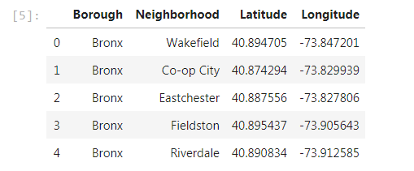

**Data2:** Newyork city geographical coordinates data will be utilized as input for the Foursquare API, that will be leveraged to provision venues information for each neighborhood. We will use the Foursquare API to explore neighborhoods in New York City. The below is image of the Foursquare API data.

In addition, Sushi category Id 4bf58dd8d48988d1d2941735 is used for retrieving data from Foursquare API.

JSON File - newyork_data.json